<https://www.schneiderdowns.com/real-estate-capital-markets>

<https://aquilacommercial.com/services/investment-services/>

<https://ergcre.com/capital-advisors/>

<https://www.international-capital.com/company-management/>

<https://www.efacademy.org/en-us/boarding-school/>

<https://www.fayschool.org/us-boarding-school-for-international-students>

<https://www.schoolsboardingusa.com/>

These websites above are the ones with content that we could emulate.

Red is a main page

***Bold italics*** is a sub page

Underline is a section within that main page or subpage

**Table of Contents：**

**Home**

“EXPERIENCED GUIDANCE TO BUILD YOUR GLOBAL REAL ESTATE PORTFOLIO”

Springer Capital: Your full service real estate advisor

Featured Deals

Our News

Contact section (standard section repetitive at the end of each page and subpage)

**About**

***About Us***

About Springer Capital

Who We Are

What We Do

How We Invest

What We Offer

***Our Team***

Meet Our Team

**Products**

***Multi Family and Student Accommodations***

Multi Family and Student Accomodation (standard section, applies to other subpage)

Our Multifamily and Student Accommodations Advisory Service  
Why Invest in Multifamily and Student Accommodations

Multi Family and Student Accommodations Property Listing (standard section, applies to other subpage)

Interested in Multi Family and Student Accommodations Investment? (standard section, applies to other subpage)

***Logistics***

Logistics

Our Logistics Advisory Service  
Why Invest in Logistics

Logistics Property Listing

Interested in Logistics Investment?

***Mixed Use***

Mixed Use

Our Mixed Use Advisory Service  
Why Invest in Mixed Use

Mixed Use Property Listing

Interested in Mixed Use Investment?

***Hospitality***

Hospitality

Our Hospitality Advisory Service  
Why Invest in Hospitality

Hospitality Property Listing

Interested in Hospitality Investment?

***Development Land***

Development Land

Our Development Land Advisory Service  
Why Invest in Development Land

Development Land Property Listing

Interested in Development Land Investment?

**Real Estate Portfolio**

**Careers**

Launching your Career in Capital Advisory

Our Supportive Team

Job Training

Apply Now Online

**News**

Real Estate News

**Contact**

Contact the Springer Capital Team

How May We Help You?

**Content**:

**Home**

“EXPERIENCED GUIDANCE TO BUILD YOUR GLOBAL REAL ESTATE PORTFOLIO”

OR

“REFINED CAPITAL STRUCTURE STRATEGY FOR REAL ESTATE”

OR

“CUSTOMIZED SOLUTIONS

UNPARALLED GROWTH.”

Our deep real estate experience will help you achieve favorable, risk-adjusted returns while offering superior customer service.

OR

We enable growth and success for our clients through deep real estate sector expertise, refined capital structure strategy, and flexible sources of capital.

(<https://www2.deloitte.com/xa/en/pages/corporate-finance/solutions/capital-advisory-services.html>)

(I think the title of this section should be a short vision/mission statement centered and bolded. We probably don’t need to explicitly say “our mission”. And beneath it a line that explains our operations.)

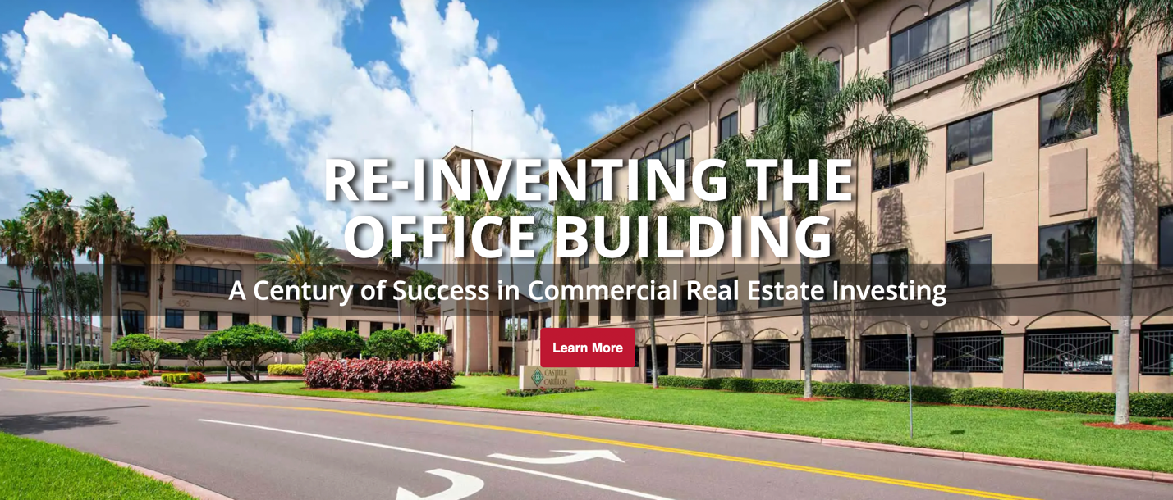

*Note: add a hyperlink through “LEARN MORE” that direct to “services” section*

Springer Capital: Your full service real estate advisor

Springer Capital is a real estate investment and advisory group with operations in Hong Kong, China, and North America.

Its founding partners are focused on world-class real estate opportunities and serve at the intersection of real estate direct investment and real estate advisory services. We leverage our breadth of global real estate investment experience with sponsors and our access to capital sources looking for yield, growth, and success.

Springer Capital offers full advisory service to its clients, ranging from optimal tax and entity structuring, cash management, accounting, asset & property management, work outs and investment reporting.

*Note: we could probably put less content but stronger statements on the home page*

Featured Deals

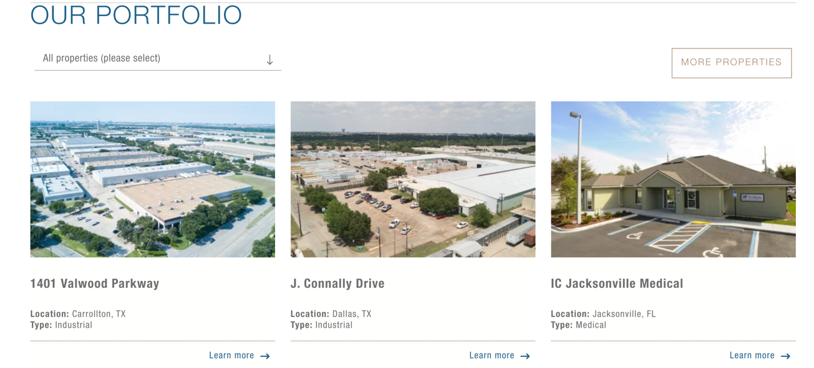

(<https://www.lotus-cp.com/>)

Note: since we don’t own portfolio of properties, we might leave this section to display some of our featured deals in the future

Our News

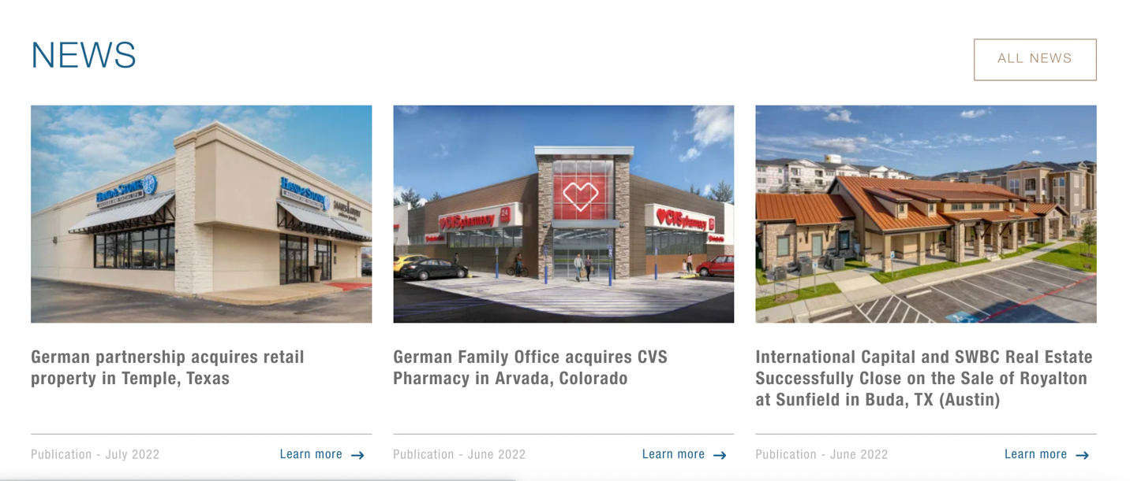

*Note: display some news and hyperlink “all news” to “news” section*

Contact section



**OR**

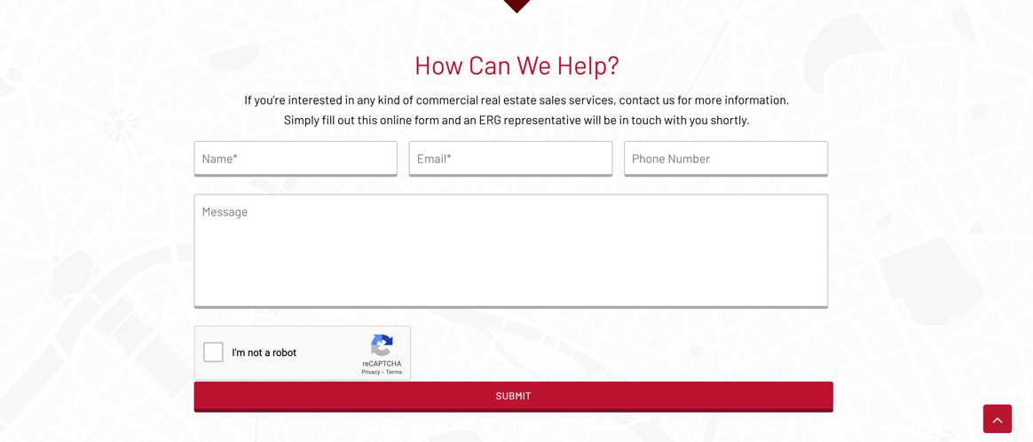

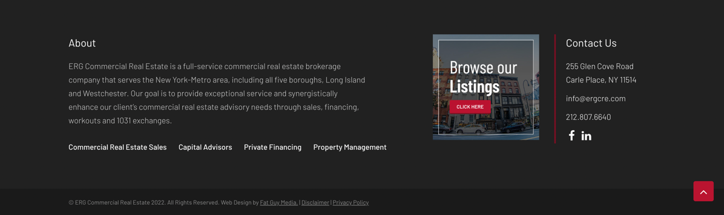

*Note: this section should be repetitive under each page; we could either use one section to display our contact info or use two sections that display a contact form +a contact info*

**About**

***About Us***

About Springer Capital

Spring Capital is a leading real estate investment and advisory group that operates in Hong Kong, China, and North America.

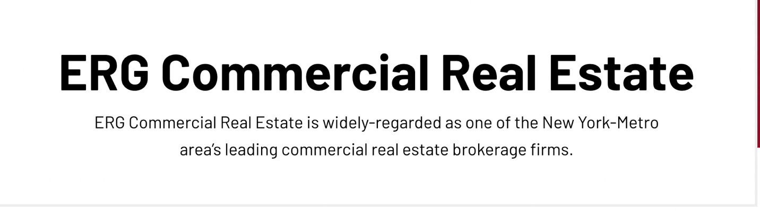

*Note: this serves as a title section*

WHO WE ARE

* We are trusted real estate investment advisors to business owners and senior executives of leading private equity firms and public and privately held companies around the world.
* We help our clients achieve superior results and strive to outperform their highest expectations with unique insights derived from deep industry relationships and a tightly integrated global team.
* We take on clients’ challenges as our own, flex our approach and methodology to meet their needs, and proactively share insights and information before, during and long after an engagement is complete.
* We adopt a rigorous analytical process and a deep respect for the numbers that are used as a baseline to drive unparalleled advice

(<https://www.lincolninternational.com/about-us/>)

WHAT WE DO

Maintain active dialogue with real estate investors covering multi family, logistics, mixed use, hospitality, development land projects across Asia and US.

Design innovative financing solutions including equity, acquisition financing, dividend recapitalization financing, structured capital that meet our clients’ needs while optimizing terms.

Leverage our financial models and data-centric strategies to support clients with actionable and measurable solutions

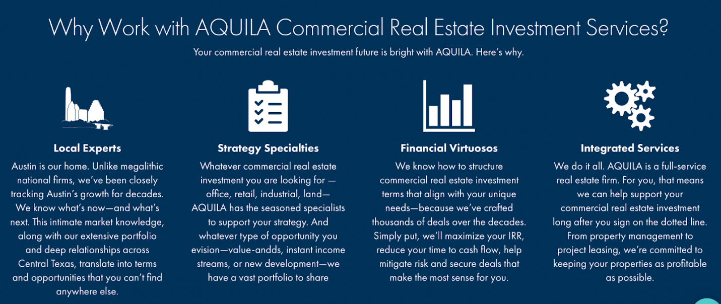

*Note: see if we could present in this way, with icons on top of content for visualization*

How We Invest -

Our investment criteria includes, but is not limited to:

Primarily limited partner equity

One-off investments rather than fund structures

Target equity ranges from $2M to $20M

Typical 3 – 5 year investment period

Focus on high growth cities

What We Offer:

1. Equity capital advisory

Springer Capital’s **Equity Capital Advisory Group**focuses on raising equity capital financing for growth-oriented, emerging enterprises ranging from early-stage ventures to more mature middle market companies. Our senior professionals work closely with entrepreneurs to secure equity capital to help fund growth initiatives, recapitalize the balance sheet, provide a level of shareholder liquidity, finance M&A transactions, or support management buyouts. Our team members integrate with the firm’s various industry groups and debt advisory group to provide our clients with maximum market coverage and holistic capital solutions.

(<https://www.capstonepartners.com/services/capital-advisory/equity-capital-advisory/>)

1. Debt capital advisory

Springer Capital boasts a highly active, fully dedicated **Debt Advisory Group** that helps privately-owned and sponsor-backed companies secure debt capital or leveraged finance for organic growth, acquisitions, dividend recapitalizations, and refinancings. The team works closely with clients to optimize their debt structures and secure the best long-term institutional partners for the business, leveraging the talents and expertise of our industry specialists to ensure that our financing strategy and positioning results in maximum credit market receptivity.

(https://www.capstonepartners.com/services/capital-advisory/debt-capital-advisory/)

***Our Team***

Meet Our Team

Springer Capital delivers ideas and solutions that make organizations better. Our arsenal of capital advisory services has been tailored to best fit the needs of our clients today and for the future.

Management:

Patrick

Patrick Kelly is a real estate professional, investor and businessman and has extensive experience in both the Chinese and North American markets. Over the years Patrick has actively been involved in many aspects of the real estate lifecycle including acquisitions, financing, development, repositioning, marketing, leasing, sales, and operations.

He frequently works as an advisor to international real estate investors, including Mr Wang Jianlin, Chairman of Dalian Wanda, where he served as GM for the Americas acquisitions team for Dalian Wanda Commercial Properties and for Mr Richard Cheung, Chairman of Sheshan International Golf Club and Estate, home of Asia’s major the WGC HSBC Champions as Director of International Development. Previously, Patrick was with Cushman and Wakefield as Head of Developer Services based in their Shanghai office.

Patrick first went to China in 1988 and was back forth several times before moving from Vancouver, settling in Shanghai in 1997. He speaks Chinese with an expat's accent and prefers English with Canadian spellings. He is married with two children.

Isaac:

Isaac Rosenthal, operating director of Greentree is responsible for investor relations, corporate strategy, internal SOPs and IT. Isaac is a serial entrepreneur who started a real estate leasing and management company Link People at the age of 23. Link People had 300 share flat apartments with 1500 tenants under management rented to young expat professionals in downtown Shanghai. In 2016, Link People was sold to Dothink Group, a top 50, Hong Kong listed Chinese real estate develo- per. Since 2017, Isaac, focused on capital fundraising and real estate acquisition projects for Dothink before joining Greentree.

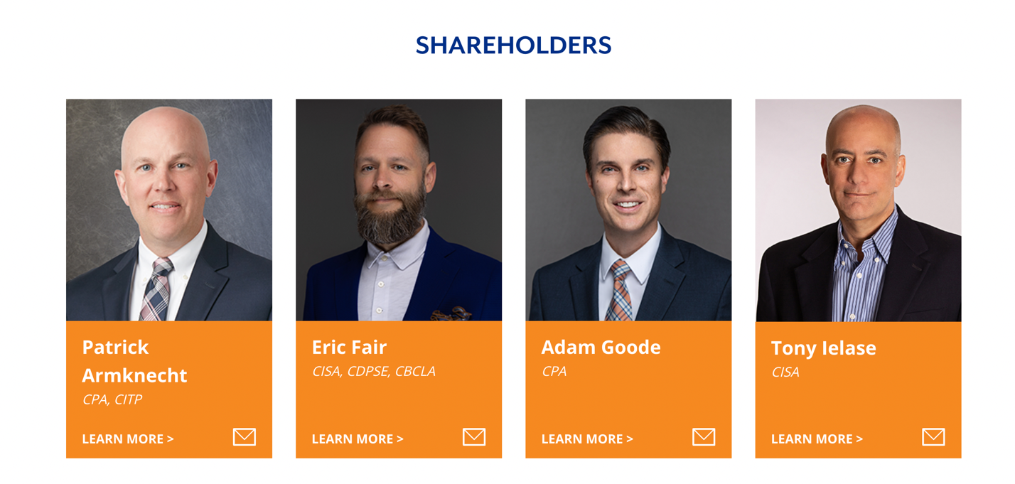

*Note: structure like this might look good*

**Products**

***Multi Family and Student Accommodations***

Multi Family and Student Accomodations

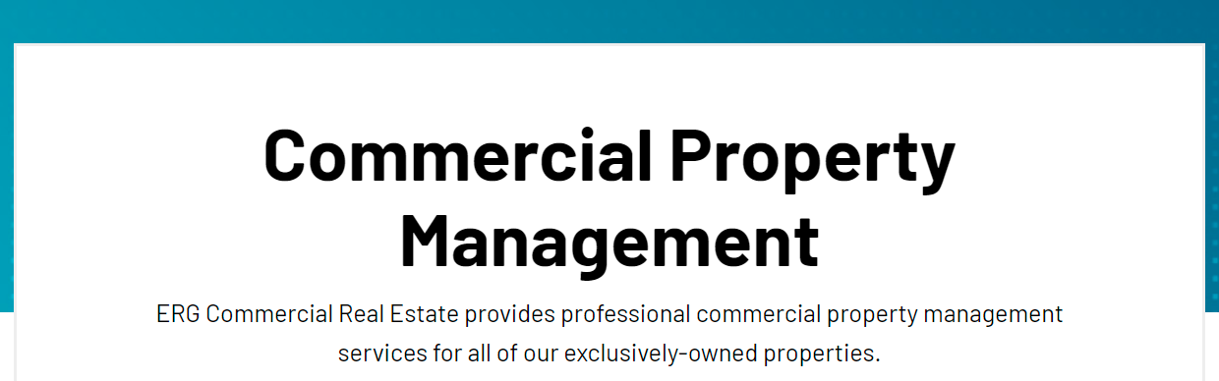 *note:Big bold and centered*

Springer Capital provides comprehensive advisory and consulting services to investors and sponsors interested in Multi-family and Student Housing real estate asset class.

Our Multifamily and Student Accommodations Advisory Service

Greentree specializes in the Multi-family and Student Housing real estate asset class. We offer a suite of consulting and support services to U.S. sponsors and developers seeking to raise capital from Asia, connecting them with our deep pool of investors. Our experienced team of professionals, utilize relevant market data to thoroughly present a sponsor’s project, experience, and capability to potential Asian investors.

Our experience and data driven process allows us to evaluate residential properties and provide owners and investors with relevant guidance on the acquisition and disposition of residential rental properties, allowing for successful growth and yield in all our projects. Our strategy and outlook are shaped by a top-down demographic study identifying and measuring sector drivers, and our project evaluation process employs a bottom up, data-driven approach in target submarkets to identify and present the best opportunities for investors.

Greentree has diversified experience within the multi-family real estate sector and a focus on the student housing sub-sector. As student housing helps colleges and universities recruit and retain students thereby distinguishing them from the competition, there is a growing need for new, cutting-edge student housing at institutions of higher education across the United States. Our team assesses the value and security of projects, assessing trends of future off-campus residencies among the top U.S. schools, to properly educate investors on the project's viability.



***Note: if possible, we could insert a photo for each section under the “Product” page except for the title and contact sections***

Why Invest in Multifamily and Student Accommodations

Multi-family assets are the most attractive investments nationwide and forecasts indicate positive trends will continue given pandemic and inflation disruptors. Additionally, given the supply and demand imbalance of multifamily housing paired with the rising interest rate environment that has become a barrier for middle-class Americans to purchase single-family homes, multifamily assets provide a solution to some of these housing obstacles.

Likewise, the rising demand for new student housing paired with the benefit of higher university recruitment and retention levels associated with state-of-the-art accommodations provides an opportunity to capitalize in this asset class.

Our team is in tune with these market challenges. At GreenTree, we offer a suite of consulting and support services to U.S. sponsors and developers of multi-family and student housing projects seeking to raise capital from Asia, connecting them with our deep pool of investors.  Our company’s data driven and market-oriented strategy yields superior results for our clients as our team of experts analyze market trends and identify opportune submarkets to fill the voids within these sectors.

Multi Family and Student Accommodations Property Listing

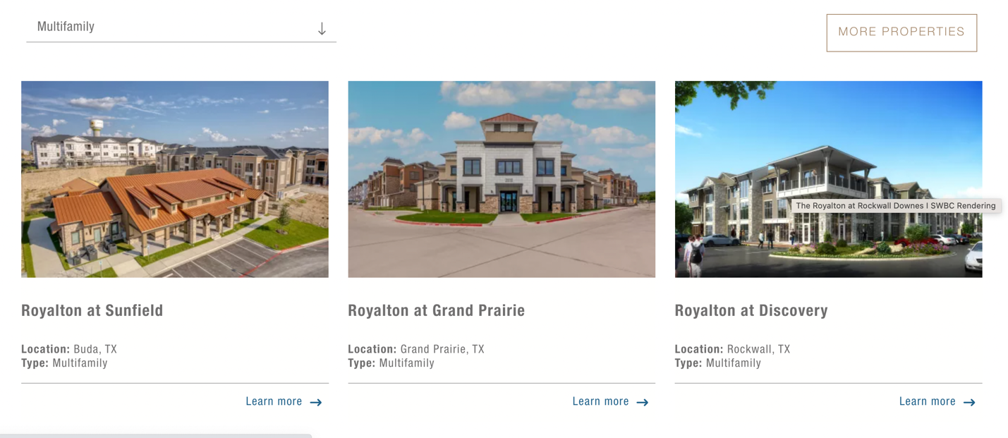

*note: this section will display a few multi family property, use “learn more” hyperlink to link to each relevant property page, and more properties to link to the property page. This applies to other subpage*

Interested In Multi Family and Student Accommodations Investment?

Multi Family Investors Contact Form

Please complete the form below to get started on acquiring capital for your multi family real estate investment.

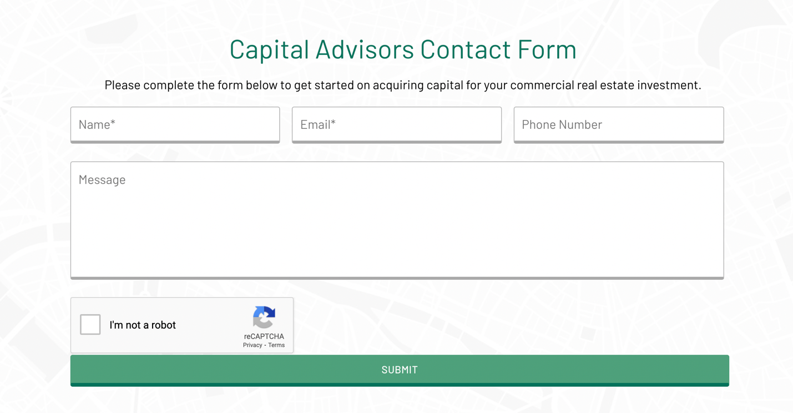

***Note: we could add this contact form under each subpage of the product page, title content dependent on the subpage title***

***Logistics***

Logistics

 *note:Big bold and centered*

Springer Capital provides comprehensive advisory and consulting services to investors and sponsors interested in Logistics real estate asset class.

Our Logistics Advisory Service

GreenTree capitalizes on an expanding e-commerce sector triggered by COVID-19 disruptors. The rising demand for additional logistics facilities to support the unprecedented growth of whole-sale providers, retailers, and third-party delivery services presents a unique opportunity for GreenTree to share its expertise and advise clients.

GreenTree acts as a provider of Asia financing for the U.S. logistics real estate business by connecting sponsors and developers of such projects to GreenTree’s expansive network of investors from the APAC region. In addition, GreenTree offers advisory services for customers aiming to target logistics market investment opportunities by consulting clients in areas such as acquisitions, sale and leasebacks, and build-to-suit developments. GreenTree provides a variety of services, including investment sourcing and acquisition, financial analysis, market analysis, contract negotiation, transaction management, and due diligence, allowing clients to make informed real estate investment decisions.

Why Invest in Logistics

We live in a fast-paced, on-demand society. The rise in e-commerce and the on-demand culture of society today has meant more need for modern, well-located industrial real estate: all types of properties where goods and products are manufactured, prepared for delivery or stored.

Urbanisation has added to that demand. The need for inner-city housing has meant higher property prices that have forced tenants in previous inner-city manufacturing and distribution hubs to seek alternative, fit-for-purpose locations close to the major cities they serve. This is happening all over the world.

These trends have combined to cause an imbalance between supply and demand: more space is needed by tenants than there is available for them to rent. And to make matters worse, any new supply is taking longer than ever to be made available because of labour and material delays exacerbated by Covid-19.

This reality means that new properties are quickly being pre-leased, and vacancy rates (the amount of space within a property that remains empty) are low across most of the world. Analysts are forecasting that low vacancy and increasing rents will continue to shape the market in 2022 and beyond.

(<https://www.hedgehog-invest.com/post/why-invest-in-industrial-logistics-real-estate>)

Logistics Property Listing

Interested In Logistics Investment?

***Mixed Use / Urban Infill Projects***

Mixed Use

Springer Capital provides comprehensive advisory and consulting services to investors and sponsors interested in mixed use real estate asset class.

Our Mixed Use Advisory Service

Springer Capital specializes in the Mixed Use real estate asset class. We offer a suite of consulting and support services to U.S. sponsors and developers seeking to raise capital from Asia, connecting them with our deep pool of investors. Our experienced team of professionals, utilize relevant market data to thoroughly present a sponsor’s project, experience, and capability to potential Asian investors.

Mixed-use is a form of integrated and pedestrian-friendly development that typically combines two or more uses, including residential, commercial, and institutional. In fact, mixed-use developments were the preferred form of living prior to the early 1900s, until increased industrialization and the automobile boom spurred the creation of suburbs as people became able to travel greater distances between residential and commercial establishments.3 Concurrently, governments imposed separate land use and zoning regulations for different purposes such as work, shopping, and schools to control the development of their respective regions.

(https://www2.deloitte.com/us/en/pages/financial-services/articles/real-estate-players.html)

Why Invest in Mixed Use

In the last few years there has been an increased demand for mixed-use developments as consumers’ preferences for integrated urban-lifestyle centers that cater to the “live, shop, work, play” mantra have become more pronounced. Interestingly, this lifestyle preference is not coming just from millennials, but also from older generations, who want to live in walkable and well-connected urban locales. Indeed, according to the 2017 National Community and Transportation Preference Survey, 62 percent of millennials, 45 percent of Gen Xers and baby boomers, and 55 percent of the silent generation want to live in walkable communities and prefer shorter commutes.

In addition to consumer demand, there are business reasons for developers to focus on mixed-use projects. First, tenants stand to benefit from increased exposure to consumers, since these spaces attract more foot traffic for diverse purposes. As a result, tenant attraction and retention can be improved through focus on mixed-use. Second, portfolio risk is diversified across different property types and uses, especially at a time when disruptive forces have rendered many single-use properties underutilized or irrelevant in a short span of time. This is true for many standalone office and retail buildings, which have lost tenants as the result of broader trends such as the sharing economy or retail store closings.

(https://www2.deloitte.com/us/en/pages/financial-services/articles/real-estate-players.html)

Mixed Use Property Listing

Interested in Mixed Use Investment?

***Hospitality / STR***

Hospitality

Springer Capital provides comprehensive advisory and consulting services to investors and sponsors interested in hospitality real estate asset class.

Our Hospitality Advisory Service

Greentree specializes in the Hopitality real estate asset class. We offer a suite of consulting and support services to U.S. sponsors and developers seeking to raise capital from Asia, connecting them with our deep pool of investors. Our experienced team of professionals, utilize relevant market data to thoroughly present a sponsor’s project, experience, and capability to potential Asian investors.

Our primary goal is to protect the integrity of the asset so that the investor can maintain and improve the future economic benefits while sustaining the physical structure. Secondly, we monitor the performance of the management company and brand to ensure compliance with respective agreements. Finally and most importantly, we work collaboratively with all parties to develop strategies and execute tactics that maximize the financial performance (EBITDA) through either revenue growth or expense control.

Our primary hospitality advisory services include:

* Hospitality Valuation
* Asset Management and Optimization
* Operational Audits
* Strategic Planning
* Cost Segregation
* Advisory Services
* General Consulting

(<https://www.kroll.com/en/services/real-estate-advisory-group/hospitality-advisory-services>)

Why Invest in Hospitality

**High return**

The number one reason that most people invest in a hotel is the high yield return that’s associated with this type of real estate investment. **The return mostly comes from the operating cash flow**. There can be drawbacks to this fact (see below). So it’s important to have an experienced management team in place to help balance the risk that comes from operating in this hospitality industry.

**Tax efficiency**

Owning a hotel gives you the advantage of possibly reducing your [tax](https://www.rcpinvestments.com/2020/05/08/the-tax-benefits-of-real-estate-investing/?utm_source=blog&utm_medium=post&utm_campaign=blog) burden. **The top three reasons for this are depreciation, equity growth, and tax-deferred exchange in business real estate**. Depreciation in hotels reduces taxable income. Other reasons that equity growth and tax deferred exchange are possible in hotels is because of investment recapitalization. This results from income derived from various physical properties inside the hotel.

**Asset diversification**

Hotels are a great avenue for investors looking to diversify their real estate investment portfolio. As we already know, diversification of investments is important. It limits your [risks](https://www.rcpinvestments.com/2021/11/29/your-real-estate-portfolio-what-should-it-include-in-2022/?utm_source=blog&utm_medium=post&utm_campaign=blog). Besides, for most investors, **investing in hotels** is not their first thought, so **there are relatively low barriers to entry**. This is a positive fact to consider.

**Value-added possibilities**

The core source of revenue from hotels is through the nightly stays and day-to-day operations. However, **one benefit of owning hotels is the flexibility to offer value-adds** to increase your income. For example, you might

* buy an older hotel and do renovations to improve quality,
* alter the way you operate to increase customer loyalty and their ensuing recommendations, or
* refine some of your major sales and service contracts.

(<https://www.rcpinvestments.com/2021/12/22/investing-in-hotels-why-add-them-to-your-portfolio/>)

Hospitality Property Listing

Interested in Hospitality Investment?

***Development Land***

Development Land

Springer Capital provides comprehensive advisory and consulting services to investors and sponsors interested in hospitality real estate asset class.

Our Development Land Advisory Service

Whether you’re an owner, investor or developer, Colliers will help you determine the best use of your land to maximize your investment. By partnering with our Land Advisory Services professionals, you can tap into the expertise of a specialized team with the technical knowledge to move your project forward. Our land advisory experts can provide you with a range of acquisition and disposition services including mapping, site planning, market analysis, and valuation and appraisal. But even more importantly, we know the key players and we know the nuances of your market.  
  
With Colliers, you have access to a well-established network of lenders, investors, developers and others you may need to work with to achieve your goals. We stay on top of the latest regulatory, environmental, transportation and legal issues to ensure you can overcome any hurdle and achieve the results you need in the shortest time possible.

(<https://www.colliers.com/en/services/land-advisory-services-practice-group>)

Why Invest in Development Land

**Less Expensive Than Buying Developed Property**

As compared to buying a developed land, the acquisition of raw land is fairly inexpensive. Not only does raw land have minimal property insurance and taxes, but it also has lower maintenance costs.

**Lower Competition**

Most investors look for developed properties, such as commercial or residential properties that can provide immediate income. In light of this fact, raw land has lower competition and can be acquired easily.

**A Wide Range of Opportunities**

Raw land offers several opportunities for investors. Not only can investors earn long-term appreciation but can also develop this land into single-family or multifamily properties and condominiums.

(<https://gcpfund.com/news/all-you-need-to-know-about-investing-in-land-development/>)

Development Land Property Listing

Interested in Development Land Investment?

**Real Estate Portfolio**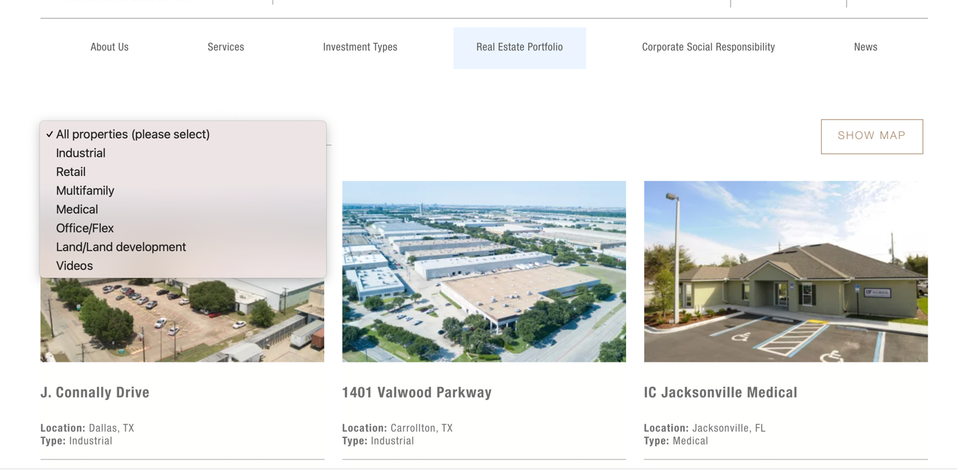

*Note: would be good to create a search and filter function according to our categories*

**Careers**

Launching your Career in Capital Advisory



If you are interested in a real estate capital advisory career, we would love to hear from you!

Our Supportive Team

Here at ERG, we are a team-oriented group that loves working together and is extremely welcoming to new employees. Everyone on our staff supports and helps one another every day. Even when leaders are out, all doors are open for advice or guidance. From the HR director to the partners, [we are all happy to help](https://ergcre.com/about-erg-commercial-real-estate/real-estate-team/).

Our team also has a contagious excitement and passion for real estate. Our salespeople work as part of small groups and receive individualized attention from their supervisors and senior staff. We believe in being competitive and pushing each other to succeed.

*Note: hyperlink back to “our team” page*

Job Training



Apply Now Online

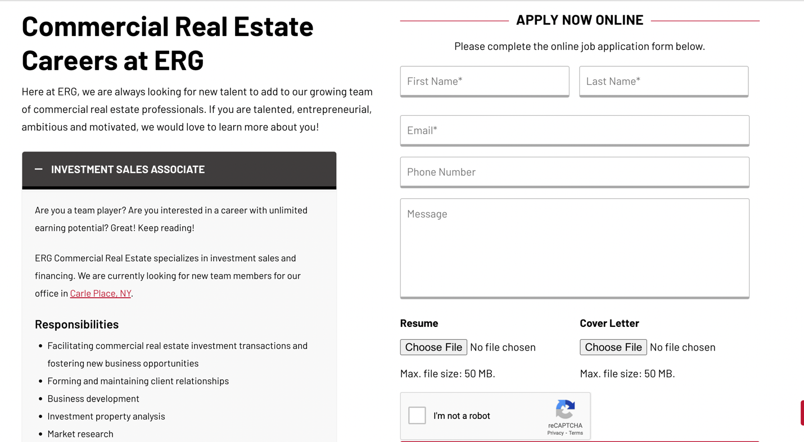

*Note: if necessary*

**News**

Real Estate News

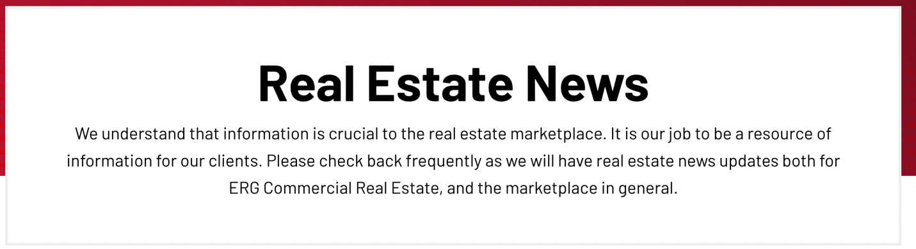

We understand that information is crucial to the real estate marketplace. It is our job to be a resource of information for our clients. Please check back frequently as we will have real estate news updates both for ERG Commercial Real Estate, and the marketplace in general.

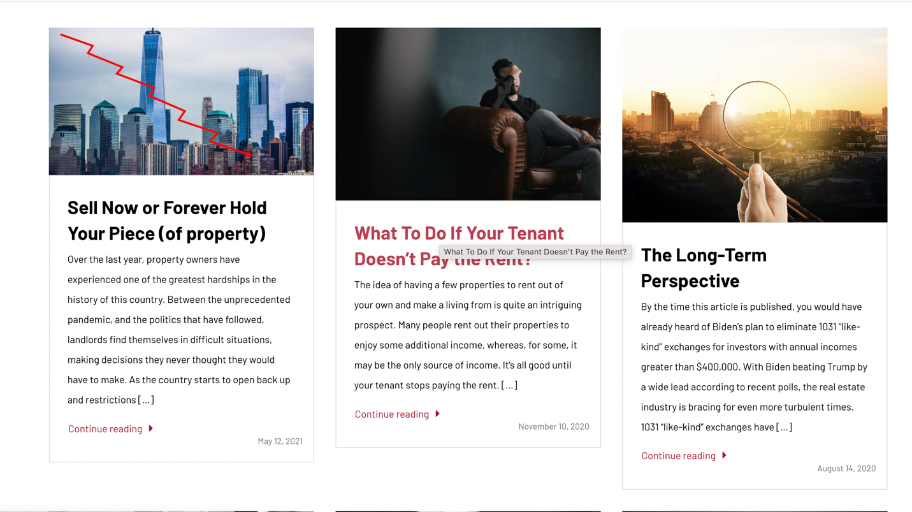

*Note: we might organize news like this*

**Contact**

Contact the Springer Capital Team

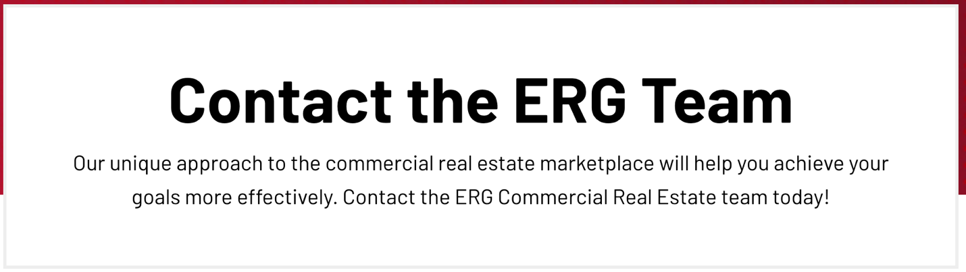

How May We Help You?

